1. Q: For each consistency error in Figure 1, you should identify the consistency rule violated and suggest possible resolutions of the error. The ERD has generic names to help will concentrate on finding diagram errors rather than focusing on the meaning of the diagram



Identified Errors:

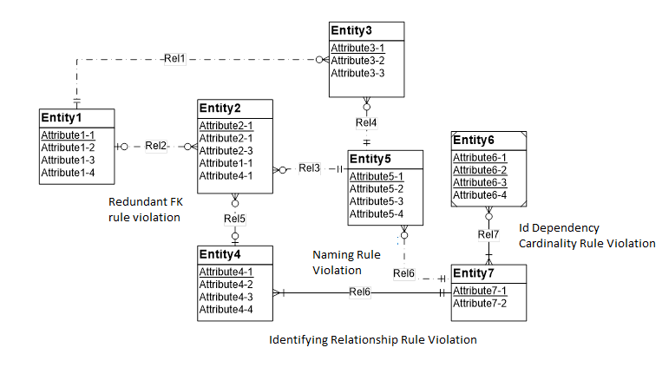

1. Redundant FK rule violation: Entity 2 has Attribute1-1 and 4-1 present in it, which violates Redundant FK rule. (Solution : Remove Attribute 1-1 and 4-1 from entity 2)
2. Identifying Relationship Rule Violation: Entity 4 and Entity 7 are connected by an identifying relationship (Rel 6) whereas both these entities are not weak entities. (Solution: Make Rel 6 a regular relationship)
3. Naming Rule Violation: Relationship between entities 5 & 7 and that between 4 & 7 both are named ‘Rel 6’, which violates naming rule. (Solution: Change name of relationship between 5 and 7 to ‘Rel 8’)
4. Identification Dependency Cardinality Rule Violation: Cardinality of weak entity(entity 6) in ‘Rel 7’is not (1, 1). (Solution : Change cardinality of weak entity to (1, 1) )

Corrected ERD is as follows:

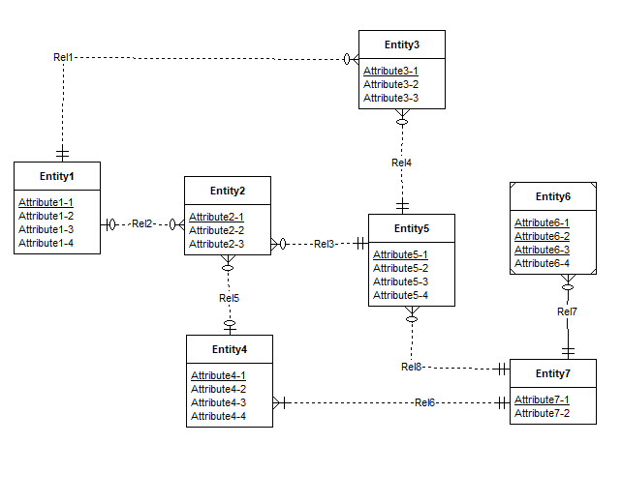

This can be verified by this report:

